TRƯỜNG ĐẠI HỌC SÀI GÒN
KHOA CÔNG NGHỆ THÔNG TIN

TEST PLAN DOCUMENT
Đề tài: ABC project
Giảng viên: TS. Đỗ Như Tài
Môn: Kiểm thử phần mềm
Lớp: DCT122C4
Danh sách các thành viên trong nhóm:
3122411151 – Phạm Thanh Phong (Trưởng nhóm)
3122411238 – Đinh Thanh Tùng
3122411156 – Lương Hoàng Phúc
3122411131 – Trần Hữu Nam
Thành phố Hồ Chí Minh – Tháng 10 2025
Mục lục
Nội dung phân công công việc 4
1. Introduction 7
1.1 Purpose of this Document 7
1.2 Overview 7
1.3 Scope 7
1.3.1 Testing Phases 7
1.3.2 Testing Types 8
1.4 Not in Scope 9
1.5 Reference Documents 9
1.6 Definitions and Acronyms 10
1.7 Assumptions and Dependencies 10
2. Test Requirement 10
2.1 Features to be Tested 10
2.2 Milestones (Schedule) 11
3. TESTING ENVIRONMENT 13
3.1 Browsers 13
3.2 Hardware and Software Requirements 13
QA 14
3.3 Human Resources 15
4. Roles And Responsibilities 16
5. TEST STRATIGY 17
5.1 Test Process Workflow 18
5.2 Test Organize / Review Project Documentation 18
5.3 Develop System Test Plan 19
5.4 Test Design/Development 19
5.5 Unit Test Execution 21
5.6 Integration/System Test Execution 22
5.6.1 Integration Testing 22
5.6.2 System Testing 23
5.6.3 Testing Types 23
• Smoke Testing 24
5.6.4 Test Execution workflow 26
5.7 Defect Tracking and Management 30
5.8 Update Documents and Results 35
5.9 Test Reports 36
5.10 UAT and Closure 37
6. Configuration management – ABC Project 39
7. Deliverables 40

Nội dung phân công công việc
STT | MSSV | Họ và tên | Công việc | Mức độ hoàn thành
1 | 3122411151 | Phạm Thanh Phong | 5. Test stratigy( 5.1 -5.6) | 100%
2 | 3122411238 | Đinh Thanh Tùng | 5. Test stratigy( 5.7 -5.10)  6. Configuration management – ABC Project  7. Deliverables | 100%
3 | 3122411156 | Lương Hoàng Phúc | 1. Introduction  2. Test requirement | 100%
4 | 3122411131 | Trần Hữu Nam | 3. Test environment  4. Roles And Responsibility | 100%

Revision History
Version / Revision Number | Author | Description | Approver | Effective Date
2.0 | Phong’s team | Test plan for ABC project

1. Introduction

1.1 Purpose of this Document

The purpose of this document is to define the test strategy, scope, and quality assurance process for the ABC Project, which is an Instant Messenger application developed for the Palm OS platform.
This Test Plan describes the testing methodology that ensures the product meets its functional and non-functional requirements while maintaining stability, usability, and compatibility with Palm OS devices.

1.2 Overview
The ABC application is designed as a standalone instant messaging client supporting the ICQ protocol on Palm OS 3.5 to 5.0.
The main objectives of this Test Plan are to:
- Ensure the system supports all required ICQ functionalities.
- Verify messaging, contact management, and connection stability.
- Validate usability and reliability of the interface and alerts.
- Confirm the system runs properly on all supported Palm OS versions and emulators.

1.3 Scope

1.3.1 Testing Phases
The following table lists the various phases of International-kids.com application testing and the team responsible for it.

Phases | Teams Responsible
Unit Testing | Development team
Integration Testing | QA Team with Developer support
System Testing | QA Team
User Acceptance Testing | Product Owner / Business Representatives
Smoke testing | Development Team (before build delivery) / QA Team (after receiving build)
Regression Testing | QA Team

1.3.2 Testing Types

International-kids.com application will undergo the following types of testing. All types of testing are explained in detail under Test Strategy section

Activity | Teams Responsible
Functionality Testing | Objective: Validate all use cases defined in the SRS — downloading/uploading contacts, adding/deleting contacts, sending/receiving messages, message history, and user status.  Performed by: QA Team during Integration/System Testing.  Completion Criteria: All functional test cases executed; all Critical and High defects resolved.
Database Testing | Objective: Ensure correct data storage, retrieval, and deletion for contacts and message history without corruption or loss.  Performed by: QA Team (with developer/DBA support if required).  Note: Since ABC stores data locally on Palm devices, offline → sync scenarios must be tested.
Security Testing | Check login authentication, session timeout, and unauthorized access prevention.
GUI and Usability Testing | Ensure interface layout, fonts, and emoticons are displayed clearly and consistently.
Performance and  Load /Volume Testing | Ensure the system performs efficiently under expected and peak usage conditions. Verify response time, stability, and system resource usage.
Code Testing | Developers perform unit and code-level testing to identify defects early before integration.
Smoke Testing | Performed by development team during Unit Testing phase and by QA during Integration/System testing to qualify the build for further tests.
Regression Testing | Performed by QA team during Integration/System testing to ensure no unwanted changes are introduced after bug fixes or updates.
Defect fix verification testing/Defect validation testing) | Performed by QA team during Integration/System testing to verify fixed defects and confirm related areas are unaffected.
Compatibility Testing | Test the app on Palm OS 3.5–5.0 and across all emulators/simulators.
Interface Testing  - Sign on | Performed by development team during Unit Testing phase. Performed by QA team during Integration/System Testing phase and by ABC project QA team during UAT phase to ensure complete end-to-end validation.  QA testing team will be responsible for testing this functionality by accessing ABC Project QA environment.
Adhoc Testing | Performed by QA team during Integration/System Testing phase to test (1) unusual navigations and (2) negative scenarios within and across modules.

1.4 Not in Scope
- Stress Testing
- Crash/Recovery Testing
- When the scope of the new application has been agreed and signed off, no further inclusions will be considered for inclusion in this release, except:
- Where there is the express permission and agreement of the Business Analyst, Project Manager and the Client;
- Where the change or inclusion does not require significant additional effort from the test team (e.g., preparing new test conditions) and does not adversely affect the testing schedule.

1.5 Reference Documents
# | Reference Document Name
1. | ABC Project Software Requirements Specification (SRS)
2. | ABC ProjectTest plan

1.6 Definitions and Acronyms
Acronym | Description
QA | Quality Assurance
SRD | Software Requirement Specification
PM | Project Manager
PL | Project Lead
TL | Technical Lead
ABC | ABC Project

1.7 Assumptions and Dependencies
- Build will be released on time for testing as per the project schedule.
- All “Show-Stopper” bugs will receive immediate attention from the development team.
- Testing of all available features in ABC Project application will be done using prepared test data and simulated Palm OS environments provided by the QA Lead.
- Enhancements will be incorporated into the original design of the ABC Project application.
- Some enhancements or UI adjustments may require further analysis; these will be reviewed during the construction phase.
- All bugs that are prioritized for the next version will be unit tested and fixed by the development team before the next release is made available.
- Functionality of the system will be delivered according to the schedule and specifications defined for the testing team during each phase.
- Required resources (Palm emulator, simulator, and test data) will be made available. The Project Manager will ensure the availability and stability of the testing environment.
- Once the source code is delivered into the QA test environment, all defects will be tracked using Mantis, which is the official defect tracking tool for the ABC Project. All bugs will be tracked under the “ABC-Messenger” project category in Mantis.

2. Test Requirement

2.1 Features to be Tested

1. General requirements | - General requirements for Home screen and Message screen of ABC Project (sending/receiving message, contact management).  - Dashboard and navigation functionality for user convenience.
2. Roles | - Functionality and access permissions of each user role (e.g., Regular User, Admin).
3. Site entry/exit | - External/Internal user login and logout validation.  - Session timeout and re-login functionality.
4.Application Submission | - Send and receive instant messages.  - View conversation history.  - Handle message delivery status (sent/delivered/failed).
5. Peer Review | - Message sending and review between users.  - Verification of message content and attachments.  - Admin review of flagged or reported messages.  - Discussion or feedback on shared content.  - Tracking message edit and delete actions.  - Generating communication reports or activity summaries.
6. General Administration | - Add or remove user accounts (Admin functionality).  - Role-based access control and permission management.  - System monitoring and maintenance.
7. Email Functions | - Initial notification alerts for new messages or friend requests.  - Maintain notification message templates.  - Email alert configuration (optional feature).

All the features to be tested will be detailed in respective Test Scenario and Test Case documents based on test types mentioned in the Scope section.
All Test Scenario documents will be delivered for review during the Pre-construction phase, and Test Case documents will be delivered during the Construction phase just before integration testing begins.
Please refer to the Deliverables section for deliverable details.

2.2 Milestones (Schedule)
NOTE: Following dates are projected with the assumption of beginning the Construction phase on 10th Oct 2025.
Actual dates will be modified as per the project plan once the construction phase begins.
Task Name | Duration | Start Date | End Date
Ramp up
Understand requirements and review docs. | 2 days | 08-Oct-2025 | 09-Oct-2025
Test Plan Development | 3 days | 13-Oct-2025 | 12-Oct-2025
Test Plan Review/Updation | 2 days | 21-Oct-2006 | 14-Oct-2025
Sign off on Test plan | 1 day | 15-Oct-2025 | 15-Oct-2025
Test Scenario Development
FunctionalArea1: Application Submission | 2 days | 16-Oct-2025 | 17-Oct-2025
Review and updation | 1 day | 18-Oct-2007 | 18-Oct-2025
FunctionalArea2: Peer Review | 2 days | 20-Oct-2007 | 21-Oct-2025
Review and updation | 1 day | 22-Oct-2007 | 22-Oct-2025
Non functionality requirements (Performance, Security, e.t.c) | 2 days | 23-Oct-2007 | 24-Oct-2025
Review and updation | 1 day | 25-Oct-2007 | 25-Oct-2025
Test Case Development
FunctionalArea1: Application Submission | 2 days | 27-Oct-2025 | 28-Oct-2025
Review and updation | 1 day | 29-Oct-2025 | 29-Oct-2025
FunctionalArea2: Peer Review | 2 days | 30-Oct-2025 | 31-Oct-2025
Review and updation | 1 day | 01-Nov-2025 | 01-Nov-2025
Non functionality requirements (Performance, Security, e.t.c) | 2 days | 03-Nov-2025 | 04-Nov-2025
Review and Updation | 1 day | 05-Nov-2025 | 05-Nov-2025
Establish Testing Environment | 2 days | 06-Nov-2025 | 07-Nov-2025
Smoke Testing | 2 days | 08-Nov-2025 | 09-Nov-2025
Functionality Testing  (Includes Functionality, Gui, Usability, Security and Database testing) | 3 days | 10-Nov-2025 | 12-Nov-2025
Regression Testing  (Includes Regression, Adhoc and Defect fix verification testing) | 3 days | 13-Nov-2025 | 15-Nov-2025
Integration Testing  (Includes External Interfaces and Module Interfaces testing) | 3 days | 17-Nov-2025 | 19-Nov-2025
Access to International-Kids.com QA Environment | 2 days | 20-Nov-2025 | 21-Nov-2025
System Testing  (Includes all types of testing mentioned above and the test types mentioned below) | 3 days | 22-Nov-2025 | 24-Nov-2025
Compatibility Testing
Performance and Load/Volume Testing
User Acceptance Testing

3. TESTING ENVIRONMENT

3.1 Browsers

Browser | Execution | Environment
Internet Explorer 6.0 | √ | Win XP
Internet Explorer 7.0 | Certification | Win XP
Mozilla Fire Fox | Certification | Win XP
Opera | Certification | Win XP

Execution of Test cases:

“√” Symbol mentioned above refers to - “Entire test cases will be executed”.
The text , “Certification” mentioned above refers to - “Selected test cases will be executed to verify the capability of the application on these browsers”.

3.2 Hardware and Software Requirements
Offshore
This section describes the environment setup offshore that is used in the development and testing of the application.
Development/ Development Integration Environment:
The Development Environment offshore corresponds to the environment used by the developers during the construction. Unit Testing on International-kids.com version is performed on this environment. Each developer machine will have International-kids.com running on Apache Web server. There will be a common MYSQL development database server and all the developers will be using the same database server.

SOFTWARE
Type | Name | Version | OS
Web Server | Apache | Apache2.0 | Windows XP
Front End Designing Tool | PHP(Personal Home Page to Hypertext Preprocessor) | PHP 4.0/5.0 | Windows XP
Scripting Language | Java script and Ajax | Java Script  Ajax | Windows XP
Database | MYSQL | MYSQL 5.0 | Windows 2000 Server  Windows 2000 Professional
Browser | IE | 6.0 | Windows XP

HARDWARE
Machine type | HDD | RAM | CPU
Web server | 40 GB | 1 GB | Intel Pentium 4, 2.66GHz
Database Server(MYSQL) | 80 GB | 1 GB | Intel Pentium 4, 2.8 GHz

QA
The QA Environment offshore corresponds to the environment on which Integration Testing is performed for International-kids.com version.
Offshore QA
SOFTWARE
Type | Name | Version | OS
Web server | Apache | Apache 2.0 | Windows XP
Scripting Language | Java Script, Ajax | Java script  Ajax | Windows XP
Database | MYSQL | MYSQL5.0 | Windows 2000 Server
Browser (Base) | IE | 6.0 | Windows XP
Browser (Certification) | IE  Mozilla Fire Fox  Opera | 7.0  6.0/7.0  4.0/5.0  9.22 | Windows XP  Windows XP  Windows XP  Windows XP

HARDWARE
Machine Type | HDD | RAM | CPU | OS | Browser
QA web server | 40 GB | 1 GB | Intel Pentium 4, 2.8 GHz | Windows XP Professional
QA Database Server(MYSQL) | 280 GB | 1 GB | Intel Pentium 4, 2.8 GHz | Windows 2000 Server
Test 1 (Desktop class) /  Base | 40 GB | 1 GB | Intel Pentium 4, 2.4 GHz | Windows XP Professional | IE6.0
Test 2 (Desktop class) / Certification | 80 GB | 1 GB | Intel Pentium 4, 2.4 GHz | Windows XP Professional | IE 7.0
Bugzilla Server | 40 GB | 1 GB | Intel Pentium 4, 2.66 GHz | Windows XP Professional

3.3 Human Resources

Resource Title | Number | Date Required | Resource name
QA lead | 1
Test Engineer  (For performing Testing of types- Functionality, Gui/Usability, Database, Smoke, Regression) | 2
Test Engineer  (For performing Testing of types- Performance, Load/Volume, Compatibility, Security, Adhoc) | 1

4. Roles And Responsibilities

Role | Responsibility | Work Ph, Mobile, Email id | Name | Secondary Role
QA lead  (Team member) | - Preparing/Updating the Test plan  - Preparing and maintaining Test Scenarios and Traceability Matrix.  - Reviewing and approving Test Cases.  - Building and deploying the application in the QA/System Integration environment for the Palm platform.  - Coordinating with the development team for version builds and release schedules.  - Preparing the Daily Test Plan* (see below for details).  - Generating the Test Summary Report at the end of each build cycle. |  |  | Project Lead / Project Manager
Tester 1/2/3  (Team member) | - Preparing and updating Test Cases based on requirements and design specifications.Reviewing the test cases  - Reviewing peer test cases for accuracy and coverage.  - Executing test cases in the Integration/System Test Environment for Palm OS builds.  - Recording and validating test results.  - Performing impact analysis for failed test cases.  - Logging, verifying, and tracking defects in Mantis Bug Tracker until closure.  - Raising issues or clarification requests via the issue tracker.  - Performing multiple test types including Functionality, Smoke, |  |  | QA lead

Daily Test plan preparation***

The QA Lead is responsible for preparing and communicating the Daily Test Plan, which shall include the following tasks:
  - Allocate and distribute workload among testers based on priority features or builds (e.g., contact management, messaging, ICQ connectivity).Plan to ensure that the tests being performed will cover all required functionality for the required OS and Browser.
  - Ensure that daily test activities cover all required functionality, environments, and device configurations on the Palm platform.
  - Maintain and update a list that defines the range of scripts and test cases to be completed each day.
  - Communicate the daily test assignments and testing goals clearly to all testers.
  - Distribute the finalized Daily Test Plan to the Project Manager and update progress reports accordingly

5. TEST STRATIGY
The Test Strategy presents the recommended approach to the testing of the ABC Development Project. The previous section on Test Requirements described what would be tested; this section describes how it will be tested.

5.1 Test Process Workflow
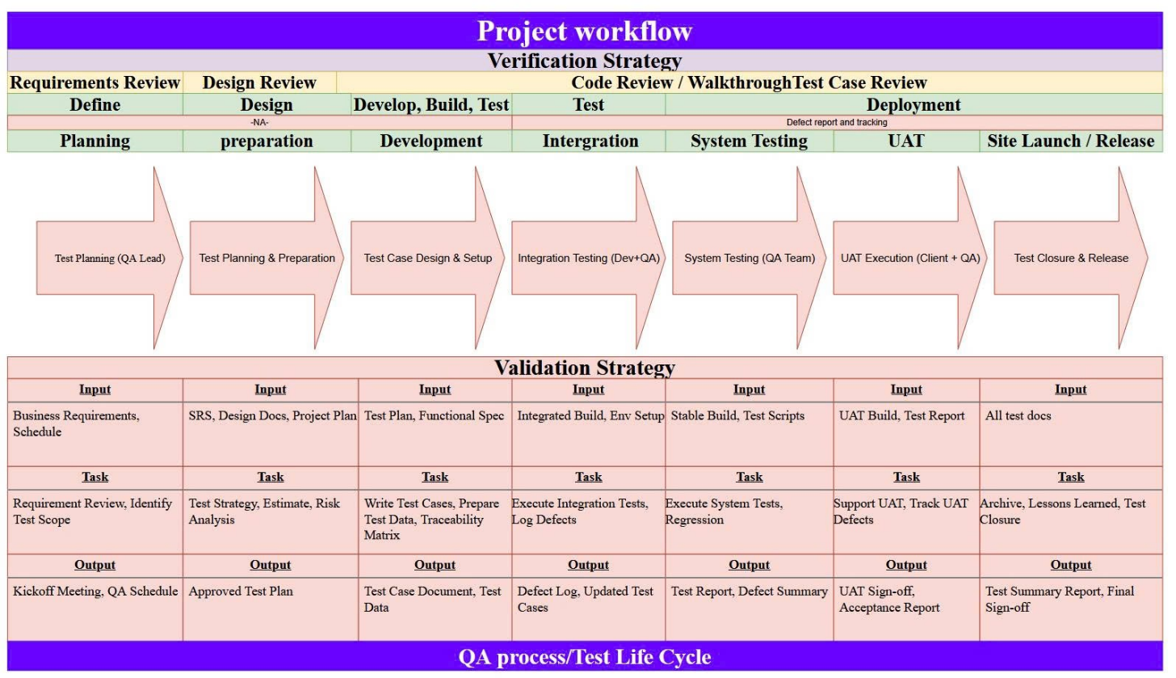

Following are the steps which explain in detail the Test Strategy to be followed for ABC Project:
Step 1. Test Organization / Review Project Documentation
Step 2. Test Planning
Step 3. Test Design and Development
Step 4. Unit Test Execution (by Developer)
Step 5. Integration and System Test Execution
Step 6. Defect Tracking and Management
Step 7. Update Documents and Test Results
Step 8. Test Reports and QA Summary
Step 9. UAT Support and Test Closure

5.2 Test Organize / Review Project Documentation
Documentation reviews ensure the accuracy, clarity, and completeness of all project documents required for the ABC Instant Messenger testing activities. Periodic reviews will be performed by the QA Team and Project Lead to verify that all specifications are consistent and testable across the Palm OS platform. These reviews will:
- Ensure that the Software Requirements Specification (SRS) clearly defines all messenger features, including account setup, contact list management, message sending/receiving, alerts, and status updates.
- Verify that Functional and Design Specifications accurately describe all workflows and user interactions supported on Palm OS 3.5–5.0 devices.
- Confirm that technical documents, including communication protocols, architecture diagrams, and emulator configurations, provide enough details for test case creation.
- Identify any missing, ambiguous, or conflicting information within project documents and recommend corrective updates before the test execution phase begins.

5.3 Develop System Test Plan
This step defines the creation of the System Test Plan for the ABC Project. The document serves as a master plan outlining the objectives, scope, approach, and resources required for system testing of the Palm Instant Messenger application.
- The Test Plan defines the testing strategy, test levels (Integration, System, UAT), test environment, and defect management process to be followed throughout the project.
- The QA Team will design and maintain all related test artifacts, including Test Scenarios, Test Cases, and Test Data, derived from the approved requirements and design documents.
- Each Test Scenario will be documented in a separate Test Scenario Specification file.
- Each Test Case will include preconditions, input data, expected results, and test steps documented in Test Case Specification sheets.
- The QA Team will coordinate with the Development Team to obtain valid ICQ service accounts, emulator setup, and Palm OS environments for functional and integration testing.
- The finalized Test Plan will be reviewed and approved by the Project Manager prior to the start of formal test execution.

5.4 Test Design/Development

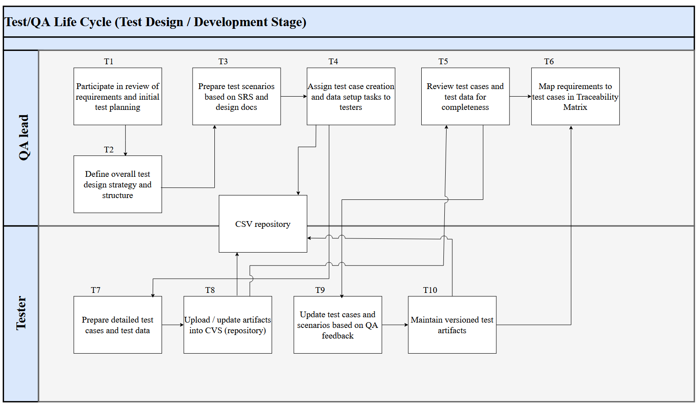

This phase defines the process for designing, developing, and maintaining test scenarios, test cases, and test scripts in alignment with the overall QA workflow described in the process flow diagram above.
The purpose of this phase is to ensure that all system functionalities and usability features of the ABC Instant Messenger application are validated systematically and traceably.
T1,T2 | The QA Lead participates in the review of project requirements and assists in preparing deliverables such as the System Test Plan.  During this phase, the QA Lead defines the overall test design strategy, including the structure of scenarios, templates, and documentation standards.  All related test artifacts are stored and version-controlled in the CVS repository.
T3, T4 | The QA Lead develops preliminary Test Scenarios based on the approved Software Requirements Specification (SRS) and Design Documents.  Once reviewed and finalized, these scenarios are checked into CVS for reference by the test team.  The QA Lead then assigns test case creation and data setup tasks to individual testers according to their assigned modules (e.g., contact management, message handling, connection management).
T5 | The QA Lead reviews test cases and test data for completeness, coverage, and consistency with the defined requirements and design documents.  Any identified issues or improvements are noted and shared with the responsible tester.
T6, T7 | Based on the approved Test Scenarios, testers create detailed Test Cases and Test Data describing the specific steps, input conditions, and expected results for each feature (e.g., adding a contact, sending and receiving messages, or managing connection status).  All created artifacts are stored and version-controlled in CVS.
T8 | After completing their assigned tasks, testers upload or update test artifacts in the CVS repository to ensure centralized access and configuration management.
T9 | The QA Lead reviews and verifies all submitted test cases and provides feedback.  Testers update the documents accordingly based on QA Lead comments to ensure accuracy and alignment with system requirements.
T10 | Finalized and reviewed test cases are versioned and maintained in the CVS repository for use in the Integration and System Testing phases.

Written Test Cases will guide the overall System Testing process.
The ABC QA Team prepares these test cases in accordance with the System Test Plan and the defined scope and objectives.
- Functional Testing: Verifies all major functionalities of the ABC Instant Messenger application — including ICQ service connection, message exchange, and contact list management.
- Data Validation: Ensures correct data transmission and synchronization across Palm OS devices and ICQ servers.
- Execution Method:
- Manual testing for Functional, Integration, and Usability areas.
- Automated testing for Performance and Load evaluation.
- Result Tracking: Each test will record Pass/Fail, defect severity, and failure cause; results are logged in Mantis for tracking.
- Performance Testing: Automated scripts assess message latency, connection stability, and system performance under concurrent user sessions.

5.5 Unit Test Execution

Unit testing is conducted to verify that each module, function, or class in the ABC Instant Messenger application performs as intended and meets the defined functional and design specifications.
A “unit” in this context refers to the smallest testable component in the system—such as message encoding/decoding logic, contact list management methods, or ICQ connection handling functions.
Each developer on the ABC project is responsible for designing, executing, and maintaining unit tests for their assigned modules.
Unit tests are executed after each successful code build within the development environment to confirm that recent code changes have not introduced defects or disrupted existing functionality.
All unit tests should validate:
- Logic correctness and data processing results.
- Input validation and boundary conditions.
- Error handling and exception responses.
- Compatibility with the Palm OS API constraints.
Unit test results must be recorded, reviewed, and version-controlled within the development repository to ensure traceability and maintainability.
A separate ABC Unit Test Strategy Document defines detailed procedures, tools, frameworks, and coding standards to be applied during the unit testing process.

5.6 Integration/System Test Execution

5.6.1 Integration Testing

The objective of Integration Testing for the ABC Project is to verify that all modules and services—such as user authentication, ICQ protocol communication, contact synchronization, and message handling—interact correctly as an integrated system.
Integration testing ensures that data exchange, communication flow, and functional dependencies between components behave as specified in the Software Design Document (SDD) and Software Requirements Specification (SRS).
Entrance Criteria
Integration testing will begin only when:
- All individual modules have successfully passed Unit Testing.
- All Severity 1 and Severity 2 defects identified during unit testing have been resolved and retested.
- The integrated build has passed configuration verification and is version-controlled.
- Build and deployment reports have been completed and approved.
- All network, emulator, and Palm OS configurations required for integration are available.
- Integration test cases and data are reviewed, approved, and accessible in the test repository.
- External dependencies (e.g., ICQ server access) are active and functional.
Exit Criteria
Integration Testing is considered complete when:
- All integrated modules have been tested according to SRS and design documentation.
- All integration-related defects are logged, reviewed, and prioritized.
- All test cases are executed, and updates have been made for approved changes.
- The Integration Test Summary Report has been completed and submitted for QA Lead review.

5.6.2 System Testing

System Testing is performed by the QA team to verify that the ABC application meets all defined business, functional, and technical requirements under realistic user and device conditions.
After successful Integration Testing, the QA team executes system test suites across all supported Palm OS versions and simulators to validate application stability, compatibility, and performance.
Entrance Criteria
- Integration Testing is complete and approved.
- Severity 1 and 2 defects are resolved and retested.
- System test cases and data are ready.
- Test environment is configured and validated.
- Required hardware, emulators, and network connectivity are available.
Exit Criteria
- All Severity 1 and 2 defects are fixed, verified, and closed.
- Severity 3 and 4 issues are documented and accepted by QA/PM.
- Regression tests have passed successfully.
- All System Test Reports and logs are submitted and approved.

5.6.3 Testing Types

The scope of testing for the ABC Instant Messenger covers multiple quality dimensions to ensure functional accuracy, data integrity, stability, usability, and performance across supported Palm OS versions.
Testing will be conducted in the following areas:

• Functionality Testing
Validates that all features—such as contact synchronization, message sending/receiving, and connection management—work as defined in:
Software Requirements Specification (SRS)
Use Case Specifications
Design Documents
Functional testing confirms correct behavior of each business process, including account setup/removal, contact management, and message operations.

• Database Testing
Ensures the accuracy and consistency of stored data within the message and contact list database.
Focus areas include:
Verification of schema elements (tables, triggers, stored queries).
Validation of data creation, retrieval, and synchronization between device and ICQ servers.
Checking data integrity, message timestamps, and contact records.
Database testing is performed alongside functional testing in each build cycle.

• User Interface / Usability Testing
Validates that all graphical elements—buttons, message fields, icons, status indicators, and alerts—are functional and user-friendly.
Tests include:
Layout and design consistency across screens.
Responsiveness of menus, toolbars, and icons.
Proper display of fonts, emoticons, and alerts.
Verification of error messages and feedback to users.

• Smoke Testing
Conducted on every build to ensure that key functionalities (login, ICQ connection, message sending) work at a high level before detailed testing begins.
Performed first by developers, then by QA after each build release.

• Adhoc Testing
Performed by experienced testers to explore the application without predefined scripts, focusing on unexpected user flows and negative conditions (e.g., network interruptions, idle timeout).

• Compatibility Testing
Verifies correct behavior across supported Palm OS versions (3.5 to 5.0) and emulator configurations.
Testing includes:
Resolution and display rendering checks.
Font and graphical alignment.
Application startup behavior across simulators.

• Security Testing
Ensures user authentication, session management, and data transmission security.
Focus areas:
Proper access control for each user account.
Prevention of unauthorized access to contact or message data.
Validation of idle timeout and auto logoff mechanisms.

• Performance and Load Testing

Assesses message delivery speed, connection stability, and performance under simultaneous user load.
Objectives include:
Verifying acceptable response times for message and contact operations.
Ensuring connection stability under concurrent sessions.
Identifying performance bottlenecks in ICQ protocol communication.
Performance tests are executed in an isolated Palm OS simulator environment using automated scripts.

• Regression Testing
Conducted after each build to ensure that new changes or defect fixes have not impacted existing functionalities.
Regression test cases cover critical paths such as login, contact synchronization, and message transmission.

5.6.4 Test Execution workflow

Test Method
The ABC test execution process follows these structured steps:
- Developers perform unit testing to verify that each function or module operates correctly and complies with design specifications.
- QA testers conduct functionality and integration testing to ensure that all modules work together and interface properly with the ICQ server and local storage.
- System Testing verifies that the complete application behaves according to business and technical requirements on all supported Palm OS versions and simulators.
- Performance and Load Testing is executed using automation tools to simulate multiple concurrent users sending and receiving messages.
- Each test case includes expected results and Pass/Fail criteria.
  - “Y” is recorded when expected results match actual outcomes.
  - “N” is recorded when they differ, and the issue is logged in Mantis.
- Defect Handling: Developers fix issues based on severity assigned by QA.
  - Severity 1: Critical failure blocking further testing.
  - Severity 2: Major defect with limited workaround.
  - Severity 3–4: Minor issues or cosmetic problems.
- After fixing, the QA team retests the related cases to confirm resolution.
- Regression Testing is executed to ensure fixes haven’t affected prior functionality.
- Traceability: All test cases, test data, and results are tracked using a Traceability Matrix.
- A dedicated test environment replicating supported hardware, emulators, and network configurations is maintained for all test cycles.

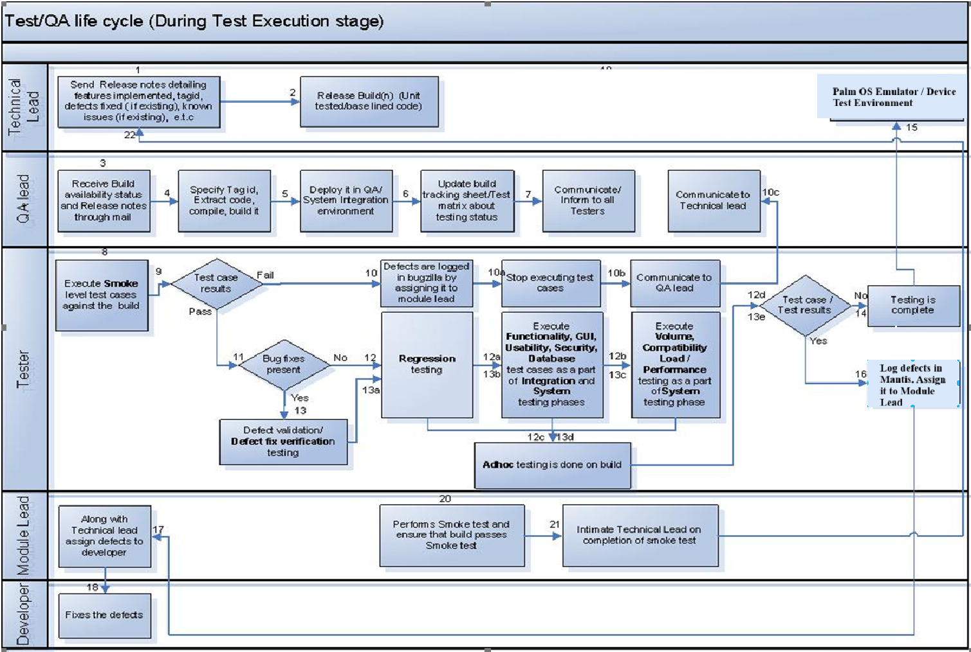
Test Flow:

Testing of the ABC Instant Messenger application will be performed at the feature level following an iterative two-week internal build release cycle.
Integration and Functionality Testing will begin as soon as the first set of core messenger features — such as login, message transmission, and contact list management — is developed and released by the development team according to the build series process.
This process will continue until the completion of System Testing.
The development team will determine and communicate the list of features included in each build release, allowing the QA team to design and review Test Scenarios and Test Cases in advance for upcoming testing cycles.
Day | Series Phase | Activities
Monday | Start of Build Series N | + Initialize test cycle and confirm environment setup (Palm OS simulator, ICQ server access, user test accounts).  + Receive Build N and Release Notes from Project Manager.  + Deploy Build N in QA test environment.  + Execute Smoke Test to verify build stability (login, send message, contact list load).
Tuesday |  | + Continue Round 1 Functional Testing — verify core messaging features, UI navigation, and contact operations.  + Log defects in issue tracker (Bugzilla).
Wednesday |  | Continue Round 1 Testing — cover new modules introduced in Build N (e.g., status update, notifications).
Thursday |  | Continue Round 1 Testing and validate fixes for previous build defects.
Friday |  | + End of Round 1 Testing — summarize results and update daily status report.  + Begin planning for Build Series N+1 (feature list, estimation, resource allocation).
Saturday
Sunday
Monday |  | Begin Round 2 Testing – focus on Integration and Regression testing (message sync, data consistency).
Tuesday |  | Continue Round 2 Testing – verify performance and compatibility on Palm OS devices.
Wednesday |  | + Continue Round 2 Testing.  + Prepare and submit updated Test Scenarios/Cases for Build N+1 review.
Thursday |  | Execute Ad-hoc and Usability testing. Log results and defects.
Friday | End of Build Series N | + Generate and submit Test Summary Report for Build N.  + Update test cases and test data based on feedback.  + Prepare environment and documents for next build (Series N+1).

Assuming that the Test Case and Script Execution process begins on January 15, 2025 (subject to schedule updates), the QA team will execute the following sequence of testing cycles for each build:
- Smoke Test Pass
  - Verifies that the current build is stable and the primary features (login, chat, and contact management) are operational.
  - Only if the Smoke Test passes will detailed testing proceed.
- Functionality Test Pass
  - Includes Functionality, GUI/Usability, Database, and Security testing.
  - Divided into two categories:
    - (1) Execution of Test Cases for features newly added in the current build.
    - (2) Re-execution of Test Cases for features from all previous builds to confirm backward stability.
- Integration Test Pass
  - Ensures that different modules and external interfaces — such as message synchronization, user presence detection, and data storage — function correctly together.
- Regression Test Pass
  - Confirms that recent code changes and bug fixes have not negatively impacted existing functionality.
  - Includes Regression, Ad-hoc, and Defect Fix Verification testing.
- System Test Pass
  - Represents the final comprehensive testing cycle, combining all testing types above.
  - Also includes Performance, Load/Volume, and Compatibility testing to ensure the application performs efficiently across different devices and Palm OS configurations.

QA Cycle  / Build Series | Duration | Smoke | Functionality |  | Integration |  | Regression | System | Test Cases/ Scenarios Updation/ Addition
QA Cycle  / Build Series | Duration | Smoke | 1 | 2 | 1 | 2 | Regression | System | Test Cases/ Scenarios Updation/ Addition
1 | 2 weeks | ✓ | ✓ |  | ✓ |  |  |  | ✓
2 | 2 weeks | ✓ | ✓ |  | ✓ |  | ✓ |  | ✓
3 | 2 weeks | ✓ | ✓ | ✓ | ✓ | ✓ | ✓ | ✓
 | 1 week Buffer time
4 | 2 weeks | ✓ | ✓ |  | ✓ |  | ✓ |  | ✓
5 | 2 weeks | ✓ | ✓ |  | ✓ |  | ✓ |  | ✓
6 | 2 weeks | ✓ | ✓ |  | ✓ |  | ✓ |  | ✓
7 | 2 weeks | ✓ | ✓ | ✓ | ✓ | ✓ | ✓ | ✓
 | 1 week Buffer time
8 | 2 weeks | ✓ | ✓ |  | ✓ |  | ✓
9 | 2 weeks | ✓ | ✓ |  | ✓ |  | ✓
10 | 2 weeks | ✓ | ✓ | ✓ | ✓ | ✓ | ✓ | ✓
11 | 2 weeks | ✓ | ✓ | ✓ | ✓ | ✓ | ✓ | ✓

5.7 Defect Tracking and Management

Purpose
The Defect Tracking and Management process for the ABC Project – Instant Messenger for Palm OS ensures that all defects identified during testing are properly logged, analyzed, resolved, and closed in an efficient and traceable manner.
The objectives of this process are to:
- Maintain a reliable defect tracking system to monitor defect status and fixes.
- Preserve a complete history of defects and corresponding resolutions.
- Ensure timely identification, notification, and correction of defects.
- Provide accurate and up-to-date reporting of defects to development and management teams.

The number of defects that surface during the QA testing period, including their potential impacts and complexity to implement, can be quite unpredictable. The PA Technical Lead / Project Manager will respond to defects in the minimum time possible, and assign fixes to a particular build. Careful review of the impact of an implemented fix will minimize reoccurrence and/or the introduction of new problems.
However, since testing alone cannot fully verify that software is complete and correct, PA takes a comprehensive validation approach. QA processes are integrated into all stages of the PA Development from the start of the engagement (e.g., large scale planning, unit testing, etc.).

The ABC QA team will use Bugzilla (or JIRA, depending on project setup) as the primary defect tracking and management tool.
This system enables the team to find, log, assign, fix, verify, resolve, and close defects throughout the testing life cycle.
- Tool URL: https://abcproject.bugtracker.com
- Project Name: ABC Messenger – Palm OS
- Access: Each QA and Development team member will be provided with an individual user ID and password.

Defects detected during QA testing may include issues such as:
- Failure to connect or authenticate with ICQ.
- Message sending or receiving delays or failures.
- Contact list synchronization errors.
- Missing or distorted graphical emoticons.
- Auto-login malfunction at startup.

Following are activities performed during Defect tracking process:

    - Execution: QA engineers execute the test cases and record actual results (Pass/Fail).
    - Defect Logging: When a test case fails, the engineer logs the defect in Bugzilla and references its ID in the test report.
    - Following Information to Record for Each Defect:
  - Bug ID
  - Summery
  - Detailed Description
  - Steps to Reproduce
  - Attachments (screenshots, logs)
  - Environment (Palm OS version, Emulator or Simulator)
  - Affected Module/Component
  - Severity
  - Owner/Assigned to
  - Status
  - Submit Date
  - Submitter/Reporter
  - Resolution

    - The defect is assigned to the QA lead, who will in turn monitor all the defects for completeness before submission to Development Tech Lead.
    - All defects will be checked for duplicate defects in Bugzilla before submission to Development Tech Lead.
    - Defects should be reproducible before being submitted to development Tech lead.
    - QA lead will monitor all defects that are in the escalation process. The defects will be classified, managed and escalated using a process agreed upon between AHA and Professional Access.
    - Tech lead along with module lead will review the defects. If a defect is valid defect, Tech lead will assign it to respective developer or else reject it by specifying the reason and re-assign it to respective reporter/submitter
    - Defects will be fixed based on severity. Those defects entered as a Severity 1 (Critical/Showstopper), or Severity 2 (High) must be corrected prior to the application being deployed. Severity 3 defects (Medium) will be corrected based on consensus agreement between Project Manager, Technical Lead and QA Test Lead regarding their criticality.
    - The person, who has been assigned the defect, carries out the impact analysis (identifies the cause of the problem, identifies the impacted components and also identifies the fix to be carried out) and then fixes the defect appropriately. He records the impact analysis briefly in the Bugzilla.
    - Integration/System test cases are updated if the defect has been escaped due to the lack of corresponding Integration/System test case and Integration/System testing that was carried out by respective Submitter/Reporter.
    - Defects if any are captured and tracked for closure using the Bugzilla.
    - The Regression testing is performed by ideally re-running Integration/System tests of the changed programs. The modified components are re-baselined on successful conclusion of these tests.
    - The product is re-integrated, revised components are built and re-running of full system and integration testing is carried out.

4) Verification and Validation: The QA Lead reviews all reported defects to check for duplicates or invalid entries before submission to the Technical Lead.
5) Assignment: The Technical Lead validates and assigns each confirmed defect to the appropriate developer or rejects it with justification.
6) Fix and Impact Analysis: The developer investigates the cause, identifies impacted modules, applies the fix, and documents the impact analysis in Bugzilla.
7) Regression Testing: QA performs regression testing to verify that the fix does not introduce new issues.
8) Closure: Once verified and confirmed as resolved, the QA Lead marks the defect as Closed in Bugzilla.

The diagram below provides an overview of the defect tracking process:

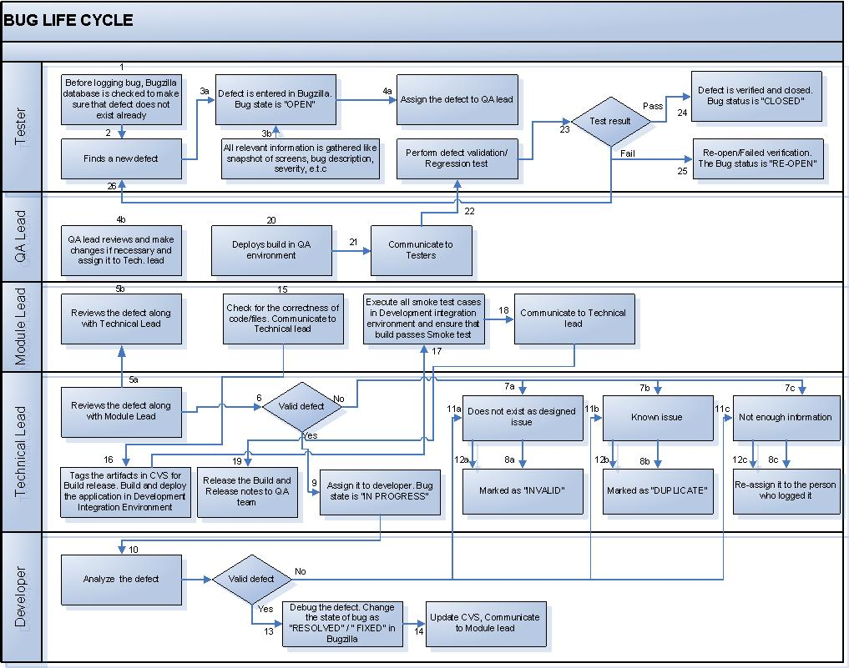

Defect Classification:

Defects identified by the PA testing team will be classified based on the guidelines explained in the subsequent sections. Apart from the guidelines, the context of a defect also has to be considered for proper classification of the defect. The defects can fall into one of the following categories:

Severity Level | Title | Description
1 | Critical/ Showstopper | - Causes global data corruption  - Missing functionality critical to site operation that was defined in specifications  - Critical function not operational (typically crash, severe application deficiency or malfunction); no work around exists  - A defect that would adversely impact the reputation of the client and is a critical business issue
2 | High/Major | - Component system hang or local data corruption.  - An Emergency defect that has been determined to have a work around.  - Non-critical function not operational; no work around. If a work around is determined to be available, then defect will be reclassified as Medium.  - Slow performance  - Examples: link broken but accessible via another click stream, garbled text in a paragraph, invalid data in a fields, unapproved content, and painfully slow downloads.
3 | Medium/Normal | - Non-critical function not operational; workaround is available  - Nonessential feature or function is missing or broken  - Operation is not user friendly or somewhat inconvenient  - Display typos or misalignments that do not affect system operation  - Bewildering dialog boxes or instructions  - Inaccurate spelling or grammar  - Functional or usage defect, which does not hamper the major usage of the application
4 | Low/Cosmetic/Minor | - Display typos or misalignments that do not affect system operation.  - An incorrect color on an element  - An incorrect object label  - Operation is somewhat inconvenient.  - This defect is not related to application functionality and mainly consists of aesthetic and usage issues

Priority:

Priority describes the importance and order in which a bug should be fixed. The available priorities are:

Priority level | Priority | Definition
P1 | High | Must be fixed immediately before the next release (blocks testing or critical functionality).
P2 | Medium | Should be resolved before the next scheduled release.
P3 | Low | Can be resolved before the final build is released.
P4 | Very low | Optional fixes or enhancements based on triage decisions.

5.8 Update Documents and Results

The objective of this section is to ensure that all test documentation, results, and related artifacts are kept up to date and accurately reflect the current testing and defect status of the ABC Project – Instant Messenger for Palm OS.
Consistent updates help maintain traceability, transparency, and control over the quality of the software throughout the testing lifecycle.

Process for Updating Documents and Results
- Test Artifacts Maintenance
  - Update test scenarios, test cases, and test scripts whenever there are changes to application functionality or workflows.
  - All modifications should be version-controlled and reviewed by the QA Lead before implementation.
- Recording Test Results
  - After each test execution, QA engineers must update the test case documents with the actual results (Pass/Fail).
  - For failed cases, the corresponding defect ID (from Bugzilla/JIRA) must be recorded in the test case result field.
- Handling New or Unusual Defects
  - If a defect is identified for which no existing test case covers the issue, a new test case must be created.
  - The new test case should then be linked to the defect reference and added to the Traceability Matrix.
- Traceability Matrix Maintenance
  - Update the Requirements Traceability Matrix (RTM) every time a new scenario or test case is added or modified.
  - Ensure every requirement in the ABC Project specification is mapped to at least one valid test case.
- Test Result Reporting
  - Develop and maintain a Daily Test Results Report, summarizing:
    - Number of executed test cases
    - Number of passed/failed cases
    - Total defects logged, verified, or closed
    - Outstanding defects by severity (Critical, High, Medium, Low)
  - Any critical issues discovered should be immediately reported to the QA Lead and Project Manager.
- Conclusion Report Preparation
  - At the end of each test cycle, the QA Lead prepares a Conclusion Report summarizing:
    - Duration and coverage of the test cycle
    - Test team members involved
    - Summary of defects logged and their status
    - Key testing metrics (defect density, test pass rate, closure rate)
    - Recommendations for future improvements
- Review and Approval
  - All updated test documents and results must be reviewed by the QA Lead and approved by the Project Manager before archiving or inclusion in release documentation.

Expected Outcomes
- Test documentation and results always reflect the most recent state of testing.
- Traceability between requirements, test cases, and defects is fully maintained.
- Test reports provide accurate, real-time visibility into project quality and readiness for release.

5.9 Test Reports

Status Reporting

    - Bugzilla will be used to log bugs. Bug report should have sufficient information to reproduce the bug
    - QA testing will be reported to the Project manager on a daily/weekly by Producing Testing Results reports.
Test Results Reports should include, but is not restricted to the following:
Report name | Fields to include
Individual project status report | Name of tester  Types of testing performed  Number of test cases/scripts executed by him/her  Number of test cases/scripts not executed by him/her  Number of defects logged (valid, Invalid, duplicate)
Test case/script execution report | Number of features available for testing  Total number of test cases/scripts generated  Number of test cases/scripts executed per tester  Types of testing performed  Percentage of total test scripts completed
Defect status report | Total number of defects logged  Total number of defects verified/closed  Total number of open defects
Defects requiring escalation report | Components/functional areas affected  Date detected  Current Status

    - QA team and Project Manager will conduct daily/weekly bug scrub meeting. The following information will be discussed.
- Current status vs. planned (are we on schedule?).
- Test cases/scripts execution completed (can be at feature level).
- Number of defects open and their severity (Bugzilla).
- Summery of QA progress
- Issues that need clarification/action

Conclusion Report
Upon conclusion of the QA test cycle, the QA/Test Lead will document the results of the test phase of the ABC Project – Instant Messenger system in the Conclusion Report. This report contains information such as:
- QA Test cycle number, duration and dates
- List of test cases executed
- Test team members
- Test case results
- Number of defects logged with status
- Metrics to quantify success of the project
- Copy of defect log

Test Summary Report

Test Summary Report would be a combination of all the above reports to present the final testing status during Intermediate/final Release.

5.10 UAT and Closure

The purpose of the User Acceptance Testing (UAT) and Closure phase in the ABC Project – Instant Messenger for Palm OS is to verify that the application meets all defined business and functional requirements, operates correctly in the target Palm OS environments, and is ready for deployment to end users.
This phase confirms that the product is stable, user-friendly, and capable of supporting ICQ-based instant-messaging features such as contact management, message exchange, and status updates.

UAT Environment
UAT will be performed on a dedicated Palm OS UAT Environment, configured and maintained by the ABC Deployment Team.
The environment will include:
- Palm OS Versions: 3.5 through 5.0
- Palm OS Emulator and Simulator with real application ROMs
- Network Connectivity: stable ICQ protocol support for send/receive testing
- Test Data: sample user accounts, contact lists, and message history
- Bug Tracking Tool: Bugzilla / JIRA (same as QA environment)
The environment must replicate production as closely as possible to ensure reliable validation results.

UAT Process
- Preparation
  - Define UAT scope, test objectives, and acceptance criteria.
  - Provide UAT test cases based on functional requirements and real user workflows.
  - Train UAT participants (end users or business representatives) on how to execute test cases and record feedback.
- Execution
  - End users perform functional testing on the Palm OS Emulator or Simulator.
  - Users validate key features such as:
    - Account creation, login, and auto-login
    - ICQ connection and disconnection
    - Sending / receiving messages
    - Contact list synchronization
    - Status updates and notifications
    - Emoticon display and fonts
  - All discovered issues are logged in Bugzilla / JIRA, classified by severity and assigned to the appropriate owner.
- Defect Resolution and Retest
  - Development Team fixes the identified defects.
  - QA Team verifies the fixes and performs regression testing to ensure stability.
  - Updated builds are provided to the UAT Team for confirmation.
- Sign-Off and Closure
  - UAT is considered complete when:
    - All planned test cases have been executed.
    - All Critical and High-severity defects are resolved and closed.
    - Regression testing has been successfully completed.
    - UAT participants formally approve the product by signing the UAT Sign-Off Document.
  - The QA Lead compiles a UAT Summary Report including execution results, defect status, outstanding issues, and final recommendations.
- Post-UAT Activities
  - Prepare the Release Readiness Checklist and submit it to the Project Manager.
  - Archive all UAT artifacts (test cases, reports, sign-off forms) in the project repository.
  - Conduct a Project Closure Meeting to review lessons learned and improvement opportunities for future releases.

Acceptance Criteria
Testing will be deemed complete and acceptable when the following conditions are met:
- All functionality, integration, and system test cases have been executed.
- All Major, Critical, and Blocker defects are fixed and verified.
- Overall defect closure rate ≥ 95%.
- No open defects that block deployment.
- All UAT documents and reports have been reviewed and approved by the ABC Project Manager and Client Representative.

Expected Outcomes
- Confirmation that the ABC Instant Messenger application functions correctly under Palm OS 3.5 – 5.0.
- All user-facing functionality (ICQ connection, messaging, contact management, auto-login, alerts) works as expected.
- The product is ready for production deployment and user release.
- Documentation of all testing results, sign-offs, and closure reports is complete.

6. Configuration management – ABC Project
The Configuration Management (CM) process for the ABC Project – Instant Messenger for Palm OS ensures that all project artifacts (documents, source code, builds, and test materials) are properly controlled, versioned, and maintained throughout the software development and testing lifecycle. Effective configuration management guarantees traceability, consistency, and reproducibility of test results, as well as secure handling of all software releases for both QA and UAT environments.
Objectives
The key objectives of configuration management in the ABC Project are to:
- Establish and maintain integrity of all project deliverables and test artifacts.
- Ensure that all software builds and test environments are properly versioned and documented.
- Prevent unauthorized changes to code, test scripts, and test data.
- Facilitate controlled deployment of software builds to QA, UAT, and Production environments.
- Provide visibility into configuration baselines and changes across the project lifecycle.

Scope
Configuration Management applies to all software components, documentation, and artifacts associated with the ABC Instant Messenger Palm OS system, including:
- Source code and executable builds
- Test plans, test cases, and scripts
- Test data and input files
- Test reports and results
- Environment configuration files (Palm Emulator, Palm OS ROMs, Simulator setup)
- User manuals and release documentation

7. Deliverables

This section defines all testing deliverables to be produced and submitted during the QA and Testing phases of the ABC Project – Instant Messenger for Palm OS. These deliverables ensure transparency, traceability, and quality control throughout the testing lifecycle.
Assumptions
The following deliverable dates are tentative and will be updated according to the official Project Plan once the testing phase begins. The construction phase is assumed to start on January 15, 2025, and deliverable dates are estimated accordingly.

Deliverable name | Description | Deliverable Date
Test plan | Detailed testing strategy, objectives, scope, approach, environment, resources, and schedule for the ABC Instant Messenger Palm OS application. | 15-Jan-2025
Test Scenarios | High-level test conditions covering all key modules: Account, Messaging, Contact, ICQ Connection, User Interface, Notifications.
Test cases | Step-by-step instructions for validating each feature and function under Palm OS 3.5–5.0 environments. Includes positive and negative test cases.
Test Data | Sample data files and predefined user accounts used for functional, integration, and regression testing.
Test Environment Setup Guide | Configuration document describing Palm OS Emulator, Simulator setup, ICQ connection settings, and deployment steps.
Defect Tracking Log | Consolidated defect list exported from Bugzilla/JIRA, including ID, severity, priority, status, and resolution details.
Test execution reports | Reports summarizing test execution progress, total test cases run, passed/failed results, and defect count.
Defect Status Reports | Daily or weekly updates on open, fixed, verified, and closed defects with trend charts.
Regression Test Reports | Results of regression testing performed after each new build or fix verification.
UAT Test Cases & Results | User Acceptance Testing documents and execution results approved by end users and client representatives.
UAT Summary & Sign-Off Report | Consolidated UAT report including defect closure summary, open issue list, and UAT sign-off confirmation.
Test summary/conclusion report | Final QA report combining all test metrics, defect statistics, and release recommendations.
Conclusion Report | Overall summary of QA activities, results, coverage, and lessons learned from the ABC Project testing phase. | 03-Mar-2025

